Folding Mountain Bike Assembly Manual

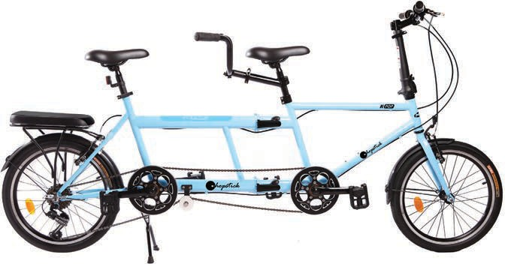

@ @) f
i
® Q) CD
® ----©
ii
@

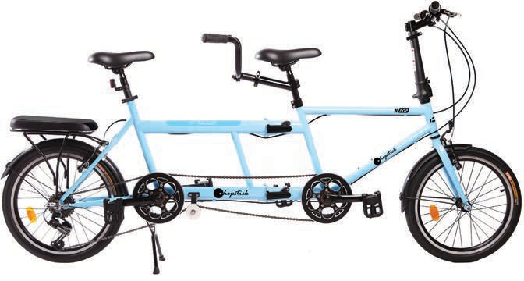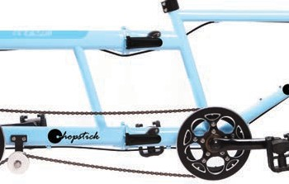
®

®--
@--
®
®-ll @-- H @ lJ&--

Frame joint connector
1

Rear Half Front Half

Lock position for riding

English

0 Dear Customer Thank you for choosing a our product. The experience, design, feature and technology of this appliance, as well as the strict quality controls used during manufacture, will provide full satisfaction for many years.
Introduction
Carefully read and understand this manual and any label attached to the tool before use. Keep these instructions with the product for future reference. Ensure all persons who use and service this product are acquainted with this manual.

- Handle Bar
- Shifters
- Brake lever
- Quick release
- Quick release
- Trye
- Front Fork
- Frame
- Front Seatpost
- Front Saddle
- Locking Shaft
- Rear Handlebar
- Rear Seatpost
- Rear Saddle
0. Rear Seat
- Rear Rack
- Mudguard
- Rim
s. Spoke
T. Rear Derailleur
u. Kick Stand
V. Chain
w. Locking Shaft
- Chain Ring
- Crank Arm
- Pedal
AA. Secondary chain ring

Dear Customer,
Please read this instruction carefully before using this item. You will find important information regarding safety of your folding Bicycle.

NOTE:
-Please read all instructions carefully before using this product.
-Consult a physician before beginning any exercise program.
-Retain This Manual for Reference.

WARNING
- Before beginning any exercise program, consult your personal physician. Evaluate your present fitness level and determine the exercise program that is most appropriate for your particular age and condition.
- If you experience any pain or tightness in your chest, irregular heartbeats, shortness of breath, faintness or other unusual discomfort while exercising, stop and consult your physician before continuing.

MAXIMUM WEIGHT CAPACITY
Folding Bike 14" = 80 Kg.
Folding Bike 16" = 80 Kg.
Folding Bike 20" = 90 Kg. Folding Bike 26" = l 00 Kg.

GENERAL SAFETY
Safe biking is an important concern for all bike manufacturers. We are constantly striving to educate our customers about safe biking habits. Using common sense is usually the best way to ride safely and get the most out of biking. Here are some common sense ideas to keep in mind whenever you ride your bike:
- Familiarize Yourself With Your State Laws.
Many states require different safety devices. It is your responsibility to familiarize with the laws of the state where you ride, and to comply with all applicable laws, including properly equipping your bicycle.
- Be Sure You Thoroughly Understand How to Operate The Components On Your Bike Many states require different safety devices. It is your responsibility to familiarize with the laws of the state where you ride, and to comply with all applicable laws, including properly equipping your bicycle.
- Always Do A Mechanical Safety Check Before Riding Be sure all the equipment is adjusted properly, especially thebrakes and that all quick release devices are in the closedposition. When you need to react in a hurry, you need toknow how your bike will respond.
- Always Ride Defensively While you may be legally in the right, in a contest between an auto and a bike, the auto will
come out first. Always be on the lookout for potentially dangerous situations.

WARNING
-GENERAL WARNING:
Bicycle can be a hazardous activity even under the best of circumstances. Proper maintenance of your bicycle is your responsibility as it helps reduce the risk of injury. This manual contains many "Warning" and "Cautions" concerning the consequences and failure to maintain or inspect your bicycle. Be sure to read and understand all of the Warnings and Cautions. Many of them refer to circumstances in which you may lose your balance and fall, which may lead to serious personal injury or death.

WEAR A HELMET
Always wear a helmet when riding your bicycle, no matter how short the ride. Always keep the chip strap securely buckled. A good helmet meeting ANSI and Snell Safety requirements offers excellent impact resistance and protection against head injury, It must fit correctly and be worn correctly to do the job properly.
WARNING: Always wear a helmet when riding a bike. Always keep the chin strap securely fastened. Failure to wear a helmet which meets the ANSI and/or Snell safety requirements may result in serious personal injury or death.

WET WEATHER
- In wet weather you need to take extra care.
- Brake earlier, you will take a longer distance to stop.
-Decrease your riding speed, avoid sudden braking and take corners with additional caution.
- Be more visible on the road.
-Wear reflective clothing and use safety lights.
-Pot holes and slippery surfaces such as line markings and train tracks all become more hazardous when wet.

NIGHT RIDING
AVOID RIDING AT NIGHT WHENEVER POSSIBLE
- Ride at night only if necessary. Slow down and use familiar roads with street lighting, if possible.
- Ensure bicycle is equipped with a full set of correctly positioned and clean reflectors.
- Use a properly functioning lighting set comprising a white front lamp and a red rear lamp.
- If using battery powered lights, make sure batteries are well charged.
- Some rear lights available have a flashing mechanism which enhances visibility.
- Wear reflective and light color clothing.

PEDALING TECHNIQUE
- Position the ball of your foot on the center of the pedal.
- When pedaling, ensure your knees are parallel to the bicycle frame.
- To absorb shock, keep your elbows slightly bent.
- Learn to operate the gears properly (for the model with gear).

SPECIAL PRECAUTIONS FOR RIDING ON THE STREET
Sharing a road with cars is a fact of life for cyclists. You can make your biking experiences more fun by applying a simple rule: make life easier for drivers. It's fruc because it's in our best interest to make the road safer, more pleasant place. Put yourself in a position where you minimize the chance for conflict with both drivers and their cars. It's your responsibility to know and obey all rules of the road. Here are a few common sense ideas that will make riding on street more fun:
l .Keep left - this most basic rule of sharing the road is the one that cyclists are
often most casual about. Avoiding hazards,
stay as far to the left as possible. Never ride against traffic.
2.Know your local bicycling riding laws - the traffic rules that motorized vehicles follow also apply to you. In addition, many states and localities have certain rules that apply to bicycles specifically, such as riding on the left-hand side of the road

in single file. Contact your local authorities for the bicycle laws for your area. 3.When riding at night, wear light colored clothes and always use a headlight and a blinking red rear light.
- Watch for pedestrians.
- Riding surface can be hazardous - be aware that even smooth roads can be dangerous, since there may be a pothole or surface condition that could cause you to lose control.
- Never ride your bike over railroad tracks - always dismount and walk your bike over the tracks. Tracks that run diagonal to streets are especially dangerous.
- When going around corners or curves, watch out for loose gravel.
- Avoid busy roads - examine a detailed map of your area and you'll probably find a relatively quiet street that takes you where you want to go.
- Riding on bike paths - bike paths have become multipurpose areas used by runners, joggers, skaters and many other non-biking related activities. Let them know you're coming by using a horn or verbal acknowledgement. Always watch out for glass and obstacles on these paths.

INSTRUCTION FOR UNFOLDING
l .Take the bike from package.
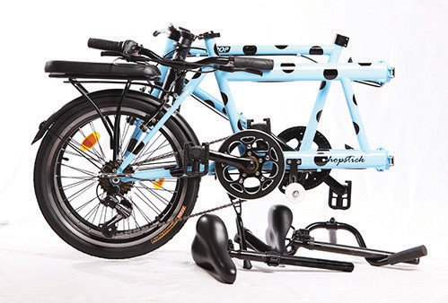

- Insert handle post and handle bar (A) adjusted quick release (E) , (DJ the desired height depends on riding person's height.
Warning: Failure to sufficiently tighten handle bar may cause handle bar to move and result in injury.

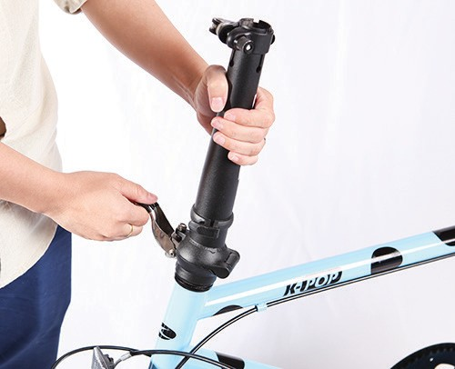
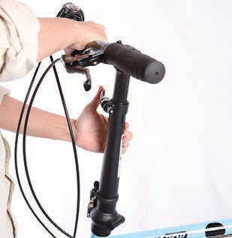

INSTRUCTION FOR UNFOLDING
- With your left hand hold handle bar (A), with right hand hold (H), unfold the bike by swinging the front & rear frame halves apart. Lock position the frame. Warning: Failure to sufficiently tighten frame joint connector may cause frame to move and result in injury.
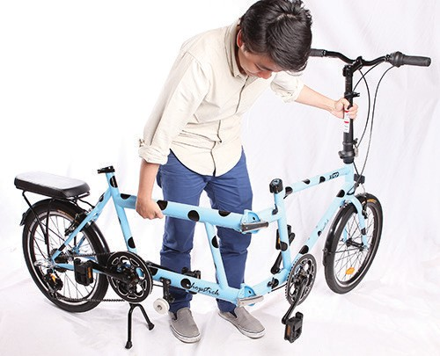
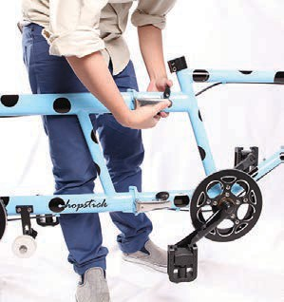

- Insert seat post (I) adjusted clockwise to tighten, the desired height depends on riding person's height.
Warning: Failure to sufficiently tighten seat post may cause to move and result in injury.
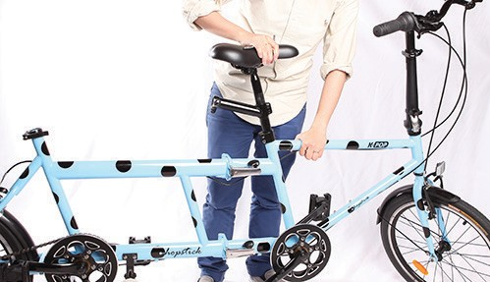

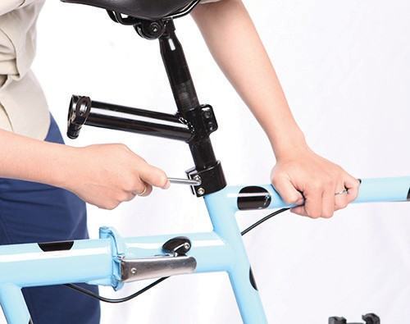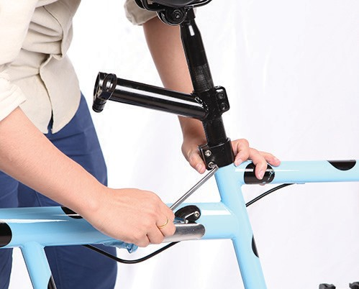

- Insert rear handle bar (L), Turn the adjusted quick release (K).
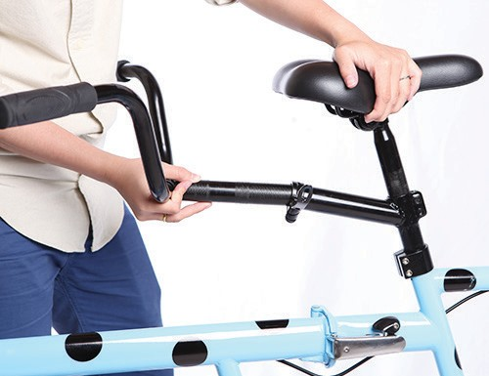
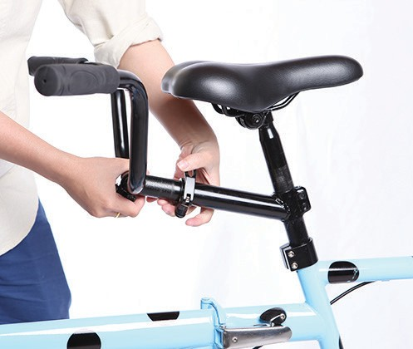

- Insert rear seat post (M) turn the adjusted quick release.

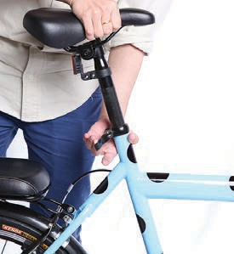

- Take the chain (V) from box, put the chain into the front chain ring.
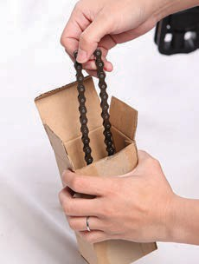
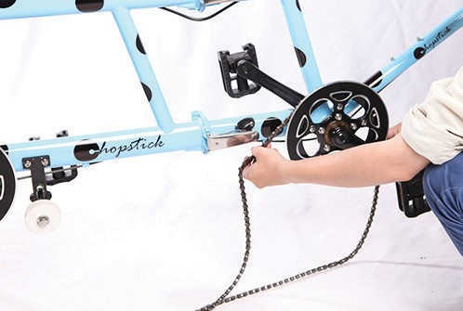

- Put the chain into the rear chain ring, and put the chain up to the secondary chain ring. Resized to fit the chain tension

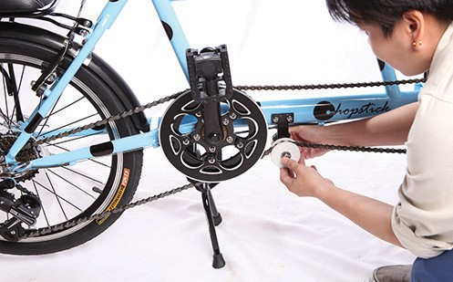

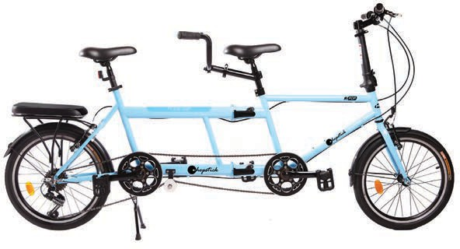

INSTUCTION FOR FOLDING

- Remove the chain from the chain ring on the back.

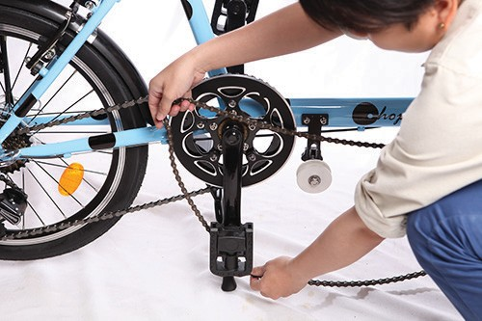

- Unlock the folded middle frame.

- With your left hand hold handle bar (A), with right hand hold (L), fold the bike by swinging the front & rear frame.
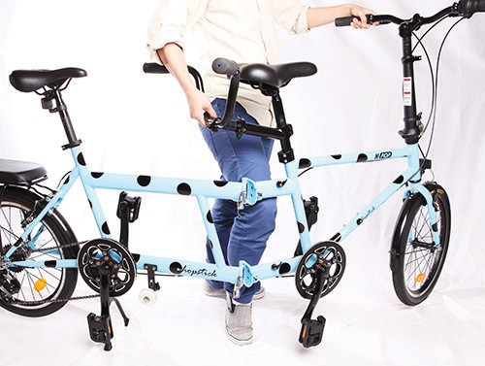
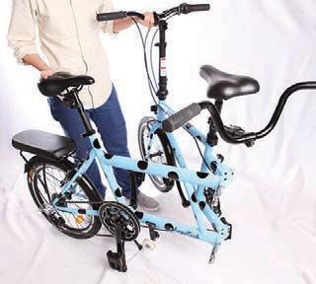

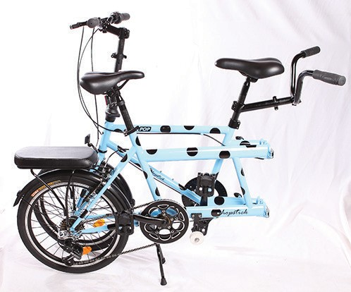

MAJOR PARTS- USAGE & CAUTION
Saddle Adjustment
The saddle can be adjusted to an angle that is most comfortable for the rider. Loosen the bolt/nut to position the saddle, the saddle should be parallel to the ground or slightly tipped back. Retighten bolt after adjustment.
Suspension Adjustment
If folding bike is a shock absorber, you can adjust the coil for better effect. For a firmer ride, tighten it so the spring is more compressed; For a shorter ride, loosen it so the spring is compressed less.
Brakes
- Before riding make sure the brake are working.
- Make sure the brake shoes do nut rub against rim.
- Adjust brakes by loosening or tightening the cable as needed, do not over tighten.
- Always brake using both brakes
- Applying brakes suddenly or with great force may make you loosed control. When riding on wet surfaces it increases your stopping distance.
Wheel and Tires
- Do not ride bike if spokes are missing. This may loosen other spokes and cause serious injury.
- Keep rims of tires clean. Use a clean rag, or wash with soap
and water. Do not clean with solvent or gasoline and avoid getting lubrication on the rim as this may affect brake performance.
- Never inflate the tires beyond maximum pressure listed on the tire. Exceeding this pressure may damage the rim and damage to the bike may cause serious injury or death.
OPERATING THE DERAILLEUR
Your bike may have 3 or 5 or 6 more gears. This system may have front and rear derailleur, cables, If Derailleur is of Shimano brand, read Shimano manual.
- The lowest gear is the easiest to pedal, while the higher gear is harder to pedal.
- Please reset the speed one by one, or the chain will drop outside or fall off easily.
- There are two kinds of front derailleur, one is derailleur lever, and the other is grip shifter. Fig. A is about the derailleur lever.
- Before ride the new bike, use cross screwdriver to tighten lightly the cross screw (4)
- ( 1) Position is for High Speed, position between ( 1) and (3) is for Medium Speed,
(3) is for Low Speed
- Do not force the shift adjuster up or down from either lowest speed or highest speed.
- After cycling the new bike for a period, the free wheel and hub will be stronger; it may cause the chain to drop or fall off when changing the speed. If this happens, you will need to adjust the screw of the derailleur as follows:
Screw 2 (see Fig.BJThe screw adjusts the chain from big gear to small one when changing the speed. Normally, the bike can be shifted from to lower gear but not fall off. If the chain does not shift higher, loosen the screw (turn left).DO NOT loosen too much or chain can fall off. If this happens, tighten the screw (turn right)

- For bicycle with more than 6 speeds derailleur, left shifter adjusts the chain wheel; right shifter adjusts the free chain. When changing the speed, please avoid the chain located in the biggest wheel of wheel chain and free chain simultaneously, smallest wheel also. In these two situations, the chain will drop outside or fall off easily as the lean of the chain is too large.
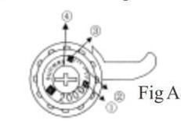
See Fig C, for adjustments to gears and brakes in detail Warning: Improper shifting can damage the gear system. Be sure pedals are turning forward while shifting gears. Never shift while at a stop.

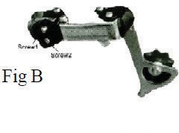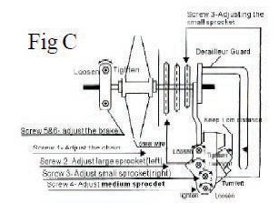

How to bicycle gears
You can think of gears as the same thing as speeds -- a bike with 18 gears is an 18-speed bike. Bikes generally have 1, 3, 18, 21, 24, or 27 speeds.
Lower numbers are the low gears, and higher numbers are the high gears. First gear is a low gear. Twenty-first gear is a high gear.
Shifting means going from one gear to another. You shift gears by sliding the shifter on the handlebars. On most bikes this shifts the chain onto a different sized ring.

How do I tell what numbers my gears are
if your bike has 10 or more speeds then it's just a little bit trickier, because you have two shifters. Let's say you have an 18-speed bike. Your left shifter will be labeled 1-2-3, and your right shifter will be labeled 1-2-3-4-5-6. This means that for each number on the left, you get six different speeds on the right, for a total of
18. Here's how it works:
The left shifter changes the ring next to the pedals. The smallest ring is 1, the middle ring is 2, and the biggest ring is 3. When you downshift with your left shifter, you're moving to a smaller ring.
The right shifter changes the ring on the rear wheel. This is opposite of the front set: On the rear wheel the biggest ring is 1, and the smallest ring is 6.
Here's pretty much all you need to know about shifting gears:
- If you're going uphill and it's too difficult, shift down.
- If your legs are spinning the pedals way too fast (it's too "easy") then shift up.

Disc Brake
Mechanical discs use the same cables and housing found on traditional cantilevers and V-brakes. Cables offer certain advantages over hydraulic systems, including simpler installation and adjustment, lighter weight, and less complicated maintenance (cables can be found at any bike shop).

How to Pump Tyres:
You should pump tyres to the volume you want. The pressure range for a tyre is listed on its sidewall (alongside the tyres diameter and width) and it's usually listed in psi (pounds per square inch) or bars. As a general rule, for a road bike it will be 80 - 130psi, mountain bike tyres will be 30 - 50psi and hybrid tyres 50 - 70psi.

CLEANING
Just like your car, your bike always looks good when it is cleaned and operating properly. Cleaning your bike does much more than just make it look good: it is vital to the reliable performance that you expect. Dirt or mud acts as a grinding compound when it gets between moving part, so the sooner you remove it, the better.
!Never wipe dried dirt without first wetting down the bike, Failure to do so will result in a scratched finish.
Cleaning after a rough ride, riding in the rain, or roads where salt us used (regional): l .Wet the bike down completely. Remove dirt or dried mud with a damp cloth. 2.Loosen and rinse debris from the chain, chain rings, derailleur and bike.
- Remove mud from the wheels, starting at the hubs and working outward of the rims.
- Allow time for the bike to dry completely before riding. DO NOT ride while wet. 5.Degrease and lubricate the chain, chainrings, derailleurs and brake pivot points. DO NOT lubricate brake pads.
- lnspect all parts to be sure everything is operating correctly, Grinding or rubbing noises indicated dirt has gotten inside components.
- Make any necessary adjustments or repairs.
- Top all this off with a liberal application of bike polish to keep your bike looking brand new.

DO NOT CLEAN RIMS WITH SOLVENT,
This can leave an oily film that renders brakes useless. Use a clean, dry rag or wash them with soap and water, rinse and let dry. Do not ride while the rims or brakes are still wet.

STORAGE
-Improper storage is very hard on a bicycle. Before storing your bike, clean, lubricate and wax it. Hang the bike off the ground with the fires at about half pressure.
-Do not store near electric motors, Ozone, a by-product of electric motors, destroys rubber and paint.
-After removing a bike from storage, be sure it is in proper working condition.

